September 2018
Miss Smith’s Newsletter
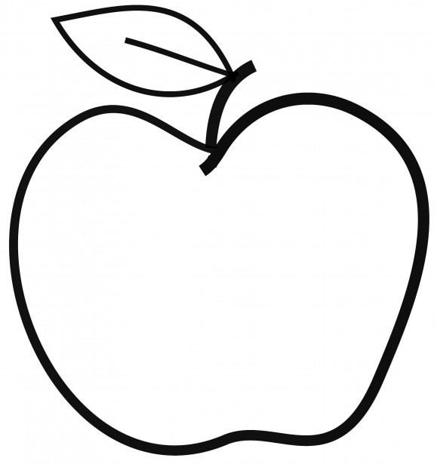

Upcoming Events

September 25
Picture Day

September 28
Popcorn Friday

October 3
Anti-Bullying Assembly

October 8
Teacher Work Day – No School
Announcements:
- Art Docents: If you are interested in being an art docent, please let me know as soon as possible!
- Volunteers: If you would like to help out in the class, send me an email with your availability and I can get you scheduled!
- Water Bottles: Please send your child to school with a water bottle each day!
- Scholastic Book orders are due Friday, September 28.

Smiths4@issaquah.wednet.edu
(425)-837-7594
https://misssmith3.weebly.com/
Here is what we are learning about this week:
Reading:
We are working on visualizing as we read a text by making mental images in our heads. Students are asked to focus on details and apply that into their writing.
Writing:
This week, we have been working on brainstorming strategies to help them get started on their narrative pieces. We have also introduced the Third-Grade checklist as a guideline for goal-setting as they begin crafting true stories.
Math:
In math, we are relating multiplication to arrays and division. We have also been introducing the commutative property (2x3=3x2) and will be working on the distributive property in the upcoming days ((5x3) + (2x3) = __).
Science/Social Studies:
We are introducing our science unit by discussing what a scientist does, what they already know about the life cycle, and what they would like to learn.
We will be starting our Social Studies curriculum in the next few weeks. We will also be continuing our Social/Emotional Learning (SEL) curriculum where we will be covering topics such as empathy, strategies for problem-solving, etc.

