September 2018
Miss Smith’s Newsletter
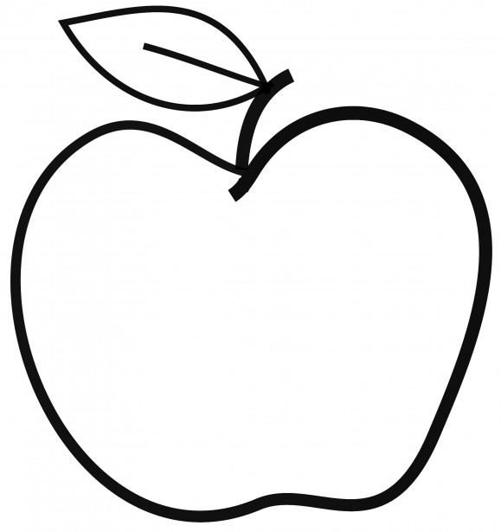

Upcoming Events

September 4
Meet the Teacher

September 5
First Day of School

September 13
Curriculum Night (7:15-8 pm)

Reminders
- Please remember to bring in your library books on Wednesdays!
- All About Me poster due Friday, September 14.
- Scholastic book orders due Friday, September 28.
- Please turn in any volunteer and field trip paperwork if you have not already.
- Newsletters will be coming home every other week to keep you updated about what is going on in Portable 3!
- Communication logs will stay in their binders. I encourage you all to have conversations with your child about what they are learning in class.
- If you have any questions or concerns, let me know!
Smiths4@issaquah.wednet.edu
(425)-837-7594
https://misssmith3.weebly.com/
Here is what we are learning about this week:
Reading:
This week, we are working on identifying character traits, making text-to-self connections, and answering comprehension questions.
Writing:
We have introduced poetry and writing about what we are looking forward to for the school year.
Math:
In math, we are working on fact fluency as well as multiplication. Specifically, we are making connections with “equal groups of” as multiplication (e.g. 2 equal groups of 6 = 12 is the same as 2 x 6 = 12).
Science/Social Studies:
This week, we are introducing our Social Emotional Learning (SEL) curriculum. These next few weeks, we will be discussing being respectful and positive self-talk. We have been reviewing class/school expectations throughout the week as well.
We will be beginning our science unit on the salmon life cycle within the next week or so.
We have also been introducing the concept of a growth mindset. Essentially, it is meant to encourage the students to maintain a positive outlook and train their brain to overcome obstacles.

