October 2018
Miss Smith’s Newsletter
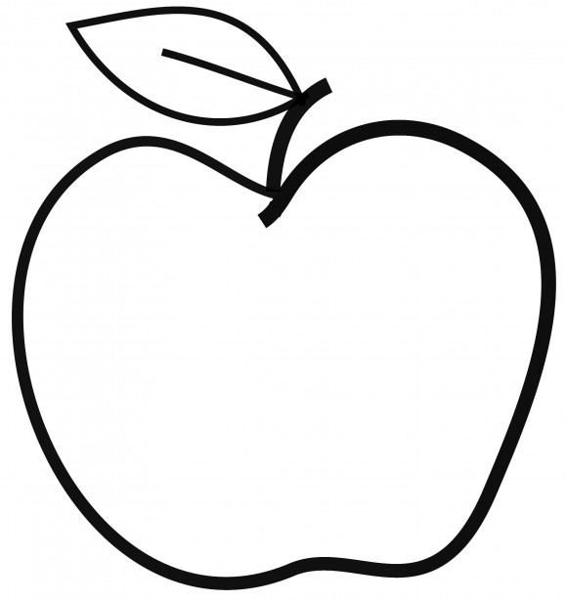

Upcoming Events

October 26
School Spirit Day – Dress as Favorite Book Character

October 26
Family Bingo Night

November 2
Popcorn Friday

Upcoming Events
- Scholastic orders are due October 31.
- If you have not done so already, please bring in your emergency pack as soon as possible.
- If you have any pictures of loved ones that you would like included in our Veteran’s Day slide show, please send them to Natalie Gerber (gerbern@issaquah.wednet.edu).
- Please remember to bring in a snack and water bottle each day!

Smiths4@issaquah.wednet.edu
(425)-837-7594
https://misssmith3.weebly.com/
Here is what we are learning about this week:
Reading:
In reading, we are practicing making inferences about character traits and feelings. We will also be comparing and contrasting characters and their traits in two separate stories by Kevin Henkes.
Writing:
In writing, we will be working on dividing our work into paragraphs and revising as we continue work on our narrative true stories.
Math:
In math, we are continuing to find connections between multiplication and division (e.g. comparing 2x4=8 with 8÷4=2). We are working more on the distributive property by breaking up a multiplication equation into pieces (e.g. 8x4 is the same as (5x4)+(3x4)).
Science/Social Studies:
In science, we are focusing on the stages of the life cycle of salmon (starting as an egg, then alevin, then fry, then smolt, then adult, and ending as a spawning adult). We have also discussed the function and purpose of different salmon parts/characteristics.
As a part of our Social-Emotional Learning (SEL), we have worked on recognizing the feelings of others as we introduce empathy.

