October 2018
Miss Smith’s Newsletter
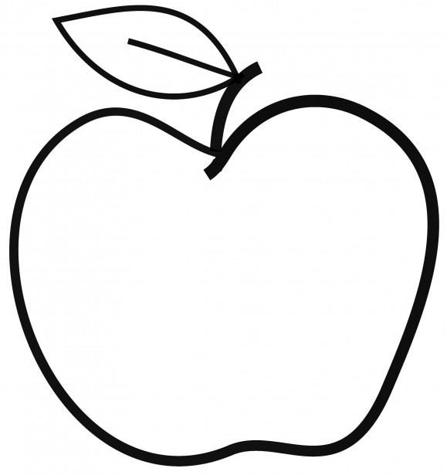

Upcoming Events

October 11
Field Trip – Salmon Hatchery

October 15
Science to Go (in-class)

October 16
Nature Vision (in-class)

Reminders
- If you haven’t already, I encourage you all to join PTA! Here is the link to join: http://challengerpta.ourschoolpages.com/home
- Turn in your emergency kits as soon as possible!
- Scholastic Book orders are due October 31.
- Remember to bring in a water bottle and snack each day if you can!
Smiths4@issaquah.wednet.edu
(425)-837-7594
https://misssmith3.weebly.com/
Here is what we are learning about this week:
Reading:
In reading, we have been working on visualizing a story as it is being told by making a mental picture. In the upcoming weeks, we will be practicing making inferences while exploring different characters and texts.
Writing:
In writing, we are continuing to work on our narrative true stories. We have introduced several strategies to get them started on their stories while also working on stamina with flash drafts. The goal is for students to get all their ideas down on paper while telling a story bit by bit.
Math:
In math, we are focusing on the commutative property (e.g. 2x4=4x2) as well as the distributive property (e.g. (5x4) + (3x4)=8x4). In the upcoming weeks, we will be exploring the relationship between multiplication and division. We will continue using number bonds and tape diagrams to solve multiplication and division problems.
Science/Social Studies:
In our Social-Emotional Learning lessons, we are discussing how to be assertive by asking for what they need/want. In science, we are covering the parts of a salmon and their functions.

