November 2018
Miss Smith’s Newsletter
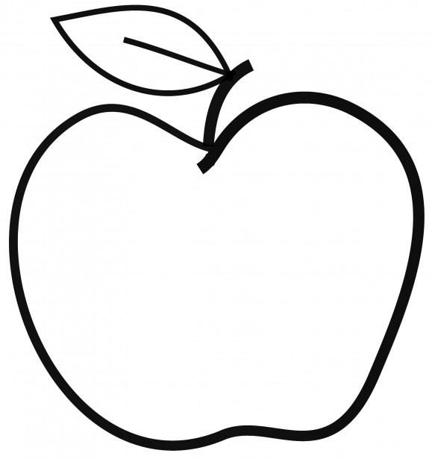

Upcoming Events

November 22-23
No School – Thanksgiving Break

December 3
Report Cards Go Home

December 5-6
Parent-Teacher Conferences – No School for Students
December 7
Popcorn Friday

Announcements:
- Scholastic orders due November 30.
- Return any pressing questions or concerns for Parent-Teacher conferences by December 3.
- Please remember to bring in emergency packs if you have not done so already.
- Reminder to bring in a water bottle and snack each day if you are able.

Smiths4@issaquah.wednet.edu
(425)-837-7594
https://misssmith3.weebly.com/
Here is what we are learning about this week:
Reading:
In reading, we will continue working on making inferences by using clues from various texts. In the upcoming weeks, we will talk about identifying themes in stories.
Writing:
In writing, we are wrapping up our unit on Narrative Writing. We are focusing on the editing and publishing stages in the writing process. Also, we are reflecting on our pieces and working to make it the best it can possible be (e.g. hook their readers, strong endings, capital letters, punctuation, spelling, etc.).
Math:
In math, we are working on measuring time using number lines and analog clocks. Later, we will begin measuring weight as well as estimating strategies.
Science/Social Studies:
In social studies, we will be covering the attributes of geography, weather and climate, cities and landmarks, resources and industry, as well as ethnicity and cultures and how they define regions.
As a part of our Social-Emotional Learning (SEL) curriculum, we will continue exploring empathy by accepting differences and showing compassion.

