November 2018
Miss Smith’s Newsletter
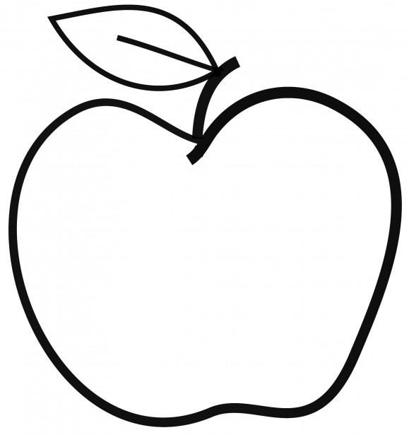

Upcoming Events

November 9
Festival of Cultures

November 12
Veteran’s Day – No School

Announcements:
- Turkey Disguise Project due November 19.
- Scholastic orders due November 30.
- Please continue reading 20-30 minutes each night!
- I will be sending out Math News’ to keep you up-to-date about what we are learning in math.
- Parent-Teacher Conferences will be held December 5 & 6. If you have not done so already, schedule a conference before November 15 at 3:30 pm on your Family Access account.

Smiths4@issaquah.wednet.edu
(425)-837-7594
https://misssmith3.weebly.com/
Here is what we are learning about this week:
Reading:
In reading, we are continuing to dive deeper into making inferences by looking closely at clues within a text. Later, we will be working on identifying themes throughout stories.
Writing:
In writing, we are continuing to work on our narrative true stories throughout the writing process. In the upcoming weeks, we will be discussing quotation marks and commas while also getting them prepared to revise and edit their work in their final drafts.
Math:
In math, we will begin working on time measurement, problem solving, as well as measuring weight and liquid volumes.
Science/Social Studies:
This winter our class will be focusing on the big idea of Geography of North America in Social Studies. This inquiry engages students in a look of where people live and allows them to begin to wonder why. They learn how the attributes of geography, weather and climate, cities and landmarks, resources and industry, ethnicity and cultures help define regions within the United States and make them desirable places to live.

As a part of our Social-Emotional Learning curriculum, we have introduced the term empathy and how to understand the perspectives of others.

