May 2019
Miss Smith’s Newsletter
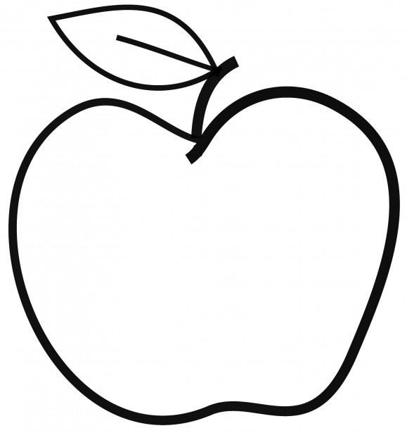

Upcoming Events

May 18
Mariner Night

May 27
Memorial Day – No School

Announcements
- SBA Testing Dates: May 16 & 17 (Math) and May 20 & 21 (ELA).
- Scholastic Orders are due May 31.
- If you have not done so already, please bring in a set of headphones or earbuds for testing.

Smiths4@issaquah.wednet.edu
(425)-837-7594
https://misssmith3.weebly.com/
Here is what we are learning about this week:
Reading:
In reading, we have been working on making inferences by combining what we know (our schema) and text evidence. Essentially, we are challenging students to read between the lines to discover information that is not stated. In small groups, we are practicing various comprehension strategies including recalling events and character development.
Writing:
In writing, we have been continuing our work on opinion texts. We have been working on editing our work and making our speeches powerful and persuasive.
Math:
In math, we are working on our unit on fractions. At the moment, we are practicing placing fractions on a number line and identifying equivalent fractions. In the upcoming weeks, we will look at comparing and ordering fractions.
Science/Social Studies:
In social studies, we are exploring various notable Americans and their contributions to history and the country. We have been exploring different texts and discussing the mark they made on society.

