Week of: March 2019
Miss Smith’s Newsletter
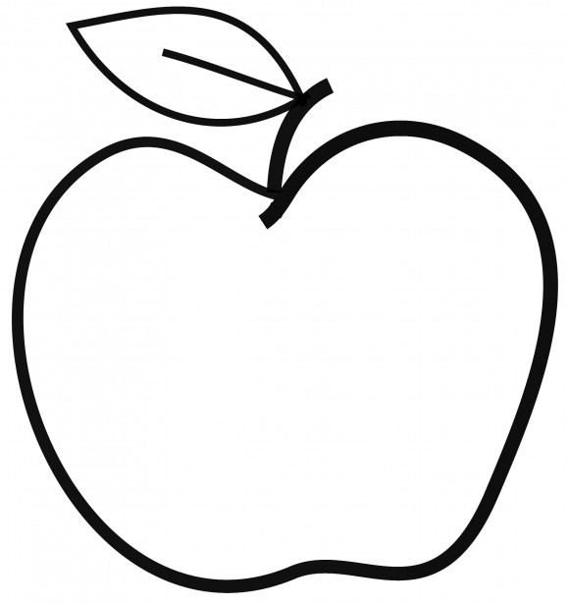

Upcoming Events

March 21
Field Trip (Wing Luke Museum)

March 26
Report Cards Available of Skyward (5 p.m.)

March 31
Last Day to Pre-order Yearbooks
April 2
Class Picture Day
April 8-12
Spring Break – No School

Announcements
- Don’t forget to bring in a daily snack/water!
- Please bring in your Field Trip permission forms as soon as possible. If I do not receive your permission form, they will not be able to go on the field trip.
- Scholastic Orders are due March 29.

Smiths4@issaquah.wednet.edu
(425)-837-7594
https://misssmith3.weebly.com/
Here is what we are learning about this week:
Reading:
In reading, we will begin looking into the different themes of books and recognizing the main idea/supporting details in texts.
Writing:
We have been working on our final drafts of our Information Writing! We have been working on self-assessing our work and incorporating skills related to elaboration, structure, and language.
Math:
In math, we are beginning our unit on area! We will be focusing on measuring area as well as their properties.
Science/Social Studies:
In Social Studies, we have been focusing on cultural universals (e.g. how people communicate, shelter, education, arts & recreated, etc.). We will continue to explore diverse cultures and learn about their own cultural universals.
As a part of our Social-Emotional Learning (SEL) curriculum, we will be discussing how to manage strong feelings (e.g. disappointment, anger, and hurt feelings). We have been reviewing Calm Down steps (1. Use your signal (“Stop”) 2. Name your feeling (“I feel…”) 3. Calm Down Strategies (counting, belly breathes, positive self-talk).

