Week of: March 2019
Miss Smith’s Newsletter
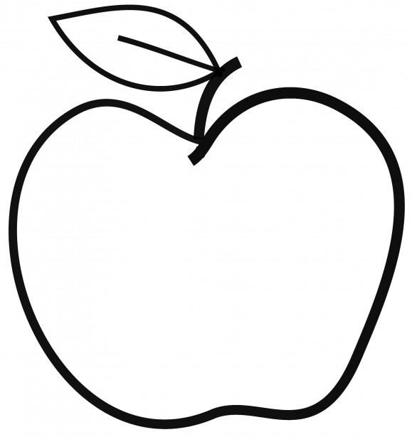

Upcoming Events

March 4
Eager Reader Begins

March 8
Mad Science Assembly
March 8
National Day of Unplugging
March 15
STEM Family Night (6-8 p.m.)
March 15
Sport Spirit Day

Announcements
- Don’t forget to bring in a daily snack/water!
- Bring in your Field Trip Permission Slip before March 15. If you are interested in chaperoning, please send your student with the green slip.
- Scholastic Orders are due March 29.

Smiths4@issaquah.wednet.edu
(425)-837-7594
https://misssmith3.weebly.com/
Here is what we are learning about this week:
Reading:
In reading, we have been exploring text features in nonfiction texts. We will continue to explore and learn about other text features in stories and articles (e.g. diagrams, headings, maps, etc.).
Writing:
In writing, we have been working on our informational pieces. Specifically, we have focused on writing powerful leads and incorporating expert language about our topic.
Math:
In math, we are continuing to introduce various strategies and recognize patterns when multiplying and dividing. We are also working on solving multi-step word problems.
Science/Social Studies:
Our class will be focusing on the big idea of Cultures of North American in Social Studies. This inquiry engages third graders in expanding their understandings of diverse cultures. The compelling question “How do cultures unify and divide us?” is intellectually respectful of students who, by their nature, are interested in people and their similarities and differences. It allows for engagement with several social studies disciplines as students examine diverse cultures.

