Week of: June 2019
Miss Smith’s Newsletter
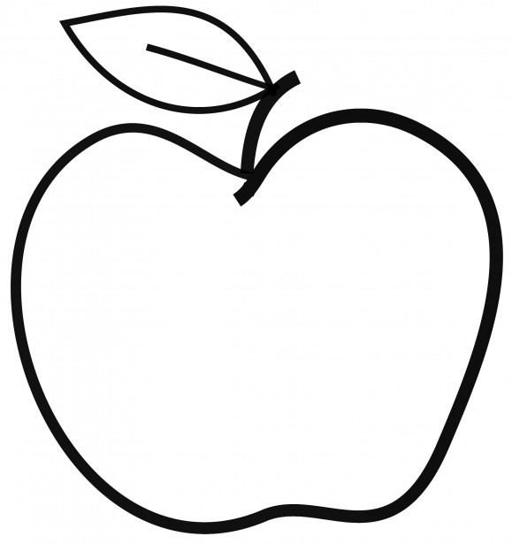

Upcoming Events
June 5-7
Book Fair

June 14
Kindness Day
June 21
Field Day

June 25
3rd Grade Class Celebration

June 26
Talent Show
June 27
Last Day of School

Smiths4@issaquah.wednet.edu
(425)-837-7594
https://misssmith3.weebly.com/
Here is what we are learning about this week:
Reading:
In reading, we are working on comprehension skills as well as summarizing.
Writing:
In writing, we have finished our final opinion pieces. We are now working on fairy tale adaptations. Students are selecting a classic fairy tale and adjusting it to make it their own.
Math:
In math, we are focusing on generating data using bar graphs, tape diagrams, and other graphs. We have also been working on interpreting measurement data with rules and line plots. We are using these types of data to problem solve and analyze data. Later, we will begin working with perimeter and looking at the attributes of shapes.
Science/Social Studies:
In social studies, we have finished our unit on Notable North Americans. Students were exploring an American that made a significant contribution to the culture and history of the country. Students then wrote a three paragraph summary talking about their person’s background, their contribution, and the effect they had on society. In the upcoming weeks, we will be covering weather as a part of our final science unit.

