January 2019
Miss Smith’s Newsletter
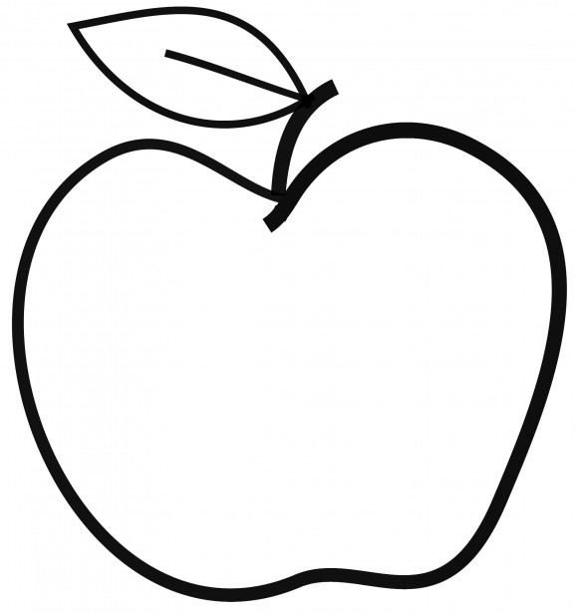

Upcoming Events

January 28
Teacher Work Day – No School for Students
January 14-15
Stuffed Animal Drive

Announcements
- Scholastic Orders due January 31.
- Please remember to bring in a daily snack and water bottle if you are able!
- If you have not done so already, please bring in any headphones or earbuds for our reading block and future testing.

Smiths4@issaquah.wednet.edu
(425)-837-7594
https://misssmith3.weebly.com/
Here is what we are learning about this week:
Reading:
In reading, we are working on the procedures for our Reader’s Workshop. Each day, students will have the opportunity to choose Word Work, Read to Self, Listen to Reading, Writing, and/or Buddy Reading. Students will be able to practice various skills related to reading and practice comprehension skills in small groups.
Writing:
In writing, we have started out Informational Writing unit! Students have been brainstorming topics that they are experts on and organizing their writing. We have been compiling a table of contents as they begin drafting their pieces of writing.
Math:
In math, we have wrapped up our unit on measurement. In the upcoming weeks, we will be focusing on multiplication and division within 10.
Science/Social Studies:
In science, we have been introducing our unit on Rocks and Minerals! We have practiced making observations and identifying specific traits for different types of rocks and minerals.
As a part of our Social-Emotional Learning (SEL), we have discussed ways to show compassion and build meaningful friendships.

