February 2019
Miss Smith’s Newsletter
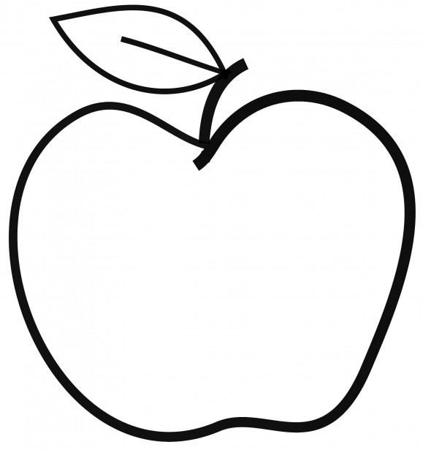

Upcoming Events

February 12
STEM Kick Off Assemblies
February 14
Valentine’s Day Celebration
February 15
Spirit Day – Mixed Up Clothes & Read My Shirt Day
February 18-22
No School – Mid-Winter Break

Announcements
- Scholastic Orders due February 28.
- Please remember to bring in a daily snack and water bottle if you are able!
- If you have not done so already, please bring in any headphones or earbuds for our reading block and future testing.
- Let me know if you are interested in running a station for our Valentine’s Day celebration.

Smiths4@issaquah.wednet.edu
(425)-837-7594
https://misssmith3.weebly.com/
Here is what we are learning about this week:
Reading:
In reading, we have introduced the main ideas and supporting details when looking at a given text. We have introduced different text features (e.g. captions, table of contents, etc.) and their purpose in stories.
Writing:
In writing, we are developing out Informational Writing about topics that they are experts on! We have been discussing what it means to use expert language, balancing facts and ideas, and setting goals for ourselves as writers.
Math:
In math, we are still working on multiplication and division strategies to build fluency. 5900
Science/Social Studies:
In science, we have been focusing on making observations about the properties of rocks and minerals. Specifically, we’ve been making observations about the feel and smell of various rocks and minerals.
As a part of our Social-Emotional Learning (SEL), we have been focusing on managing strong feelings with calm down strategies.

