December 2018
Miss Smith’s Newsletter
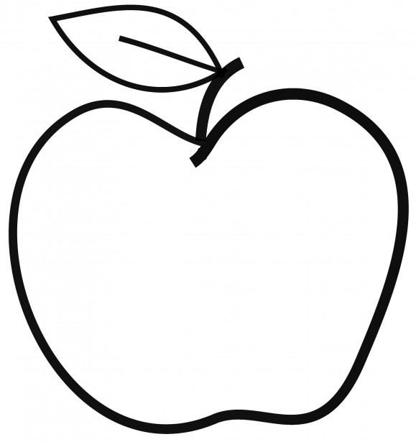

Upcoming Events

December 5 & 6
Parent-Teacher Conferences

December 7
Popcorn Friday

December 18 (1:50-2:20 pm)
Winter Sharing Concert

December 20 – January 1

Winter Break

Announcements
- Scholastic Orders due December 10 so books can be distributed before break.
- Please remember to bring in a daily snack if you are able!
- If you have any on hand, please have your third-grader bring in any headphones for our reading block and future testing.

Smiths4@issaquah.wednet.edu
(425)-837-7594
https://misssmith3.weebly.com/
Here is what we are learning about this week:
Reading:
In reading, we are working on questioning strategies to use as they are reading. We are working on self-monitoring for comprehension and finding “just right” books. Later, we will be introducing theme and how to determine the overall message of a story.
Writing:
In writing, we have finished our Narrative Unit and have been working hard to create our final published drafts! We will be celebrating and sharing all of hard work in the upcoming days.
Math:
In math, we are continuing our unit on measurement. Specifically, we are focusing on measuring time, weight, and volume using units of measure (e.g. kilograms, grams, liters, etc.).
Science/Social Studies:
In social studies, we are exploring a particular region in the United States (e.g. Southwest, Southeast, West, Midwest, and Northeast). We have been making statements about our assigned regions and finding concrete evidence to support those claims.
As a part of our Social-Emotional (SEL) curriculum, we are discussing how to show compassion for others as well as friendship-building exercises.

