April 2019
Miss Smith’s Newsletter
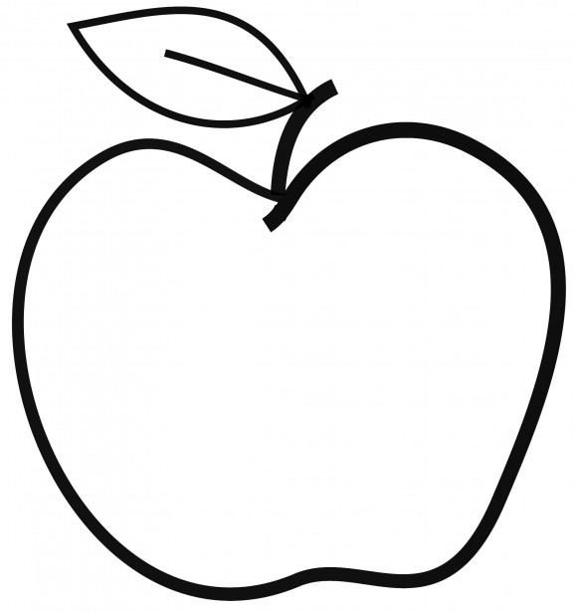

Upcoming Events

May 3
Color Run (after-school) & Popcorn Friday

May 18
Mariner Night

May 27
Memorial Day – No School

Announcements
- SBA Testing Dates: May 16 & 17 (Math) and May 20 & 21 (ELA).
- Scholastic Orders are due April 30.
- If you have not done so already, please bring in a set of headphones or earbuds for testing.

Smiths4@issaquah.wednet.edu
(425)-837-7594
https://misssmith3.weebly.com/
Here is what we are learning about this week:
Reading:
In reading, we have been focusing on identifying main messages/themes in stories. In small groups, we have been focusing on various skills including summarizing what they have read.
Writing:
In writing, we have been continuing our work on opinion texts. We have been working on setting goals while also making a plan for our writing. Students are encouraged to use their Third Grade Checklist to self-assess their writing in various areas as they go (structure, development, and language conventions).
Math:
In math, we are in the midst of our unit on fractions. So far, we have worked on partitioning into equal parts and relating a fraction to a whole. In the upcoming weeks, we will be working with fractions on a number line, equal fractions, and comparing fractions.
Science/Social Studies:
In social studies, we have finished our unit on cultural universals. Students were asked to research a particular country and identify the cultural universals that are common in that area (e.g. food, economy, transportation, clothing, etc.). In the next unit, we will be exploring notable Americans through biographies and other activities.

